How To Create a Personal Website on GitHub

**By: Roberto Mandujano III**

The first step to building your personal website is to create a [GitHub](https://github.com/) account by following these [steps](https://youtu.be/PxGDLdcg3oQ).

Once you have created your account you will have to sign in and follow the steps provided below:

1. Click on ***Repositories.***
2. Click on ***New***

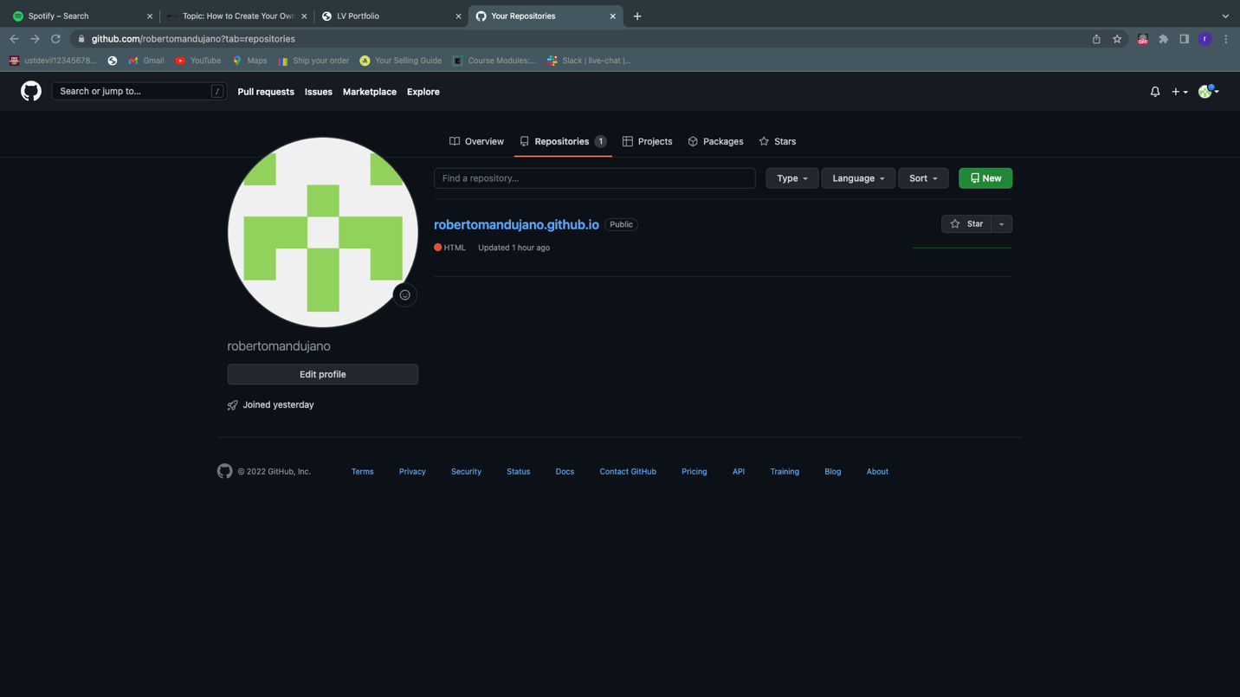

1. Enter “yourusername.github.io” under ***Repository name.***
2. Click on ***Create repository***.

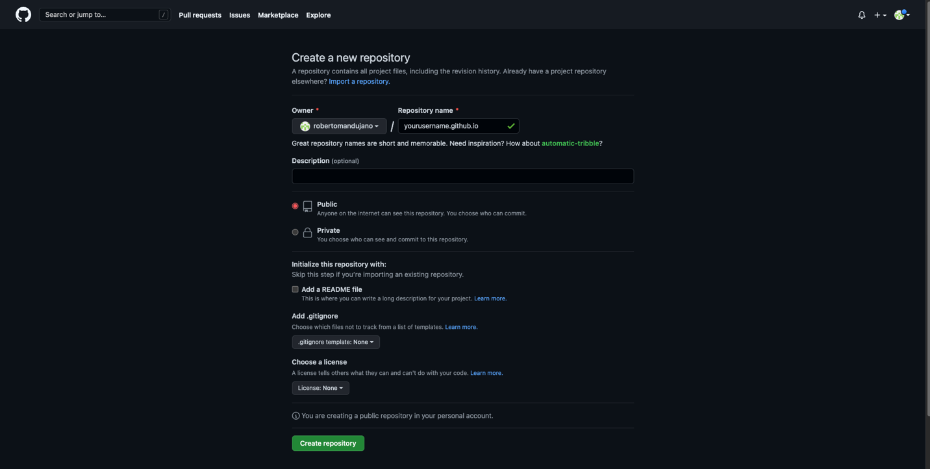

1. Set up initial files on ***VS Code***. (Note: type in code as you see on the image below).

1. Click on ***upload existing file***.

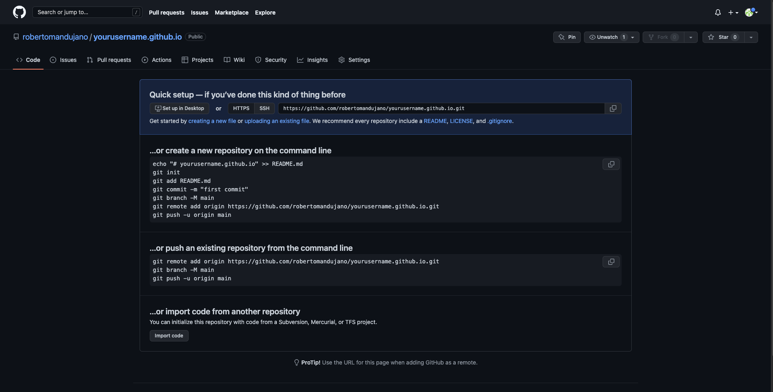

1. Drag images or HTML files containing content that you would want displayed on your website.
2. Click ***Commit changes***.

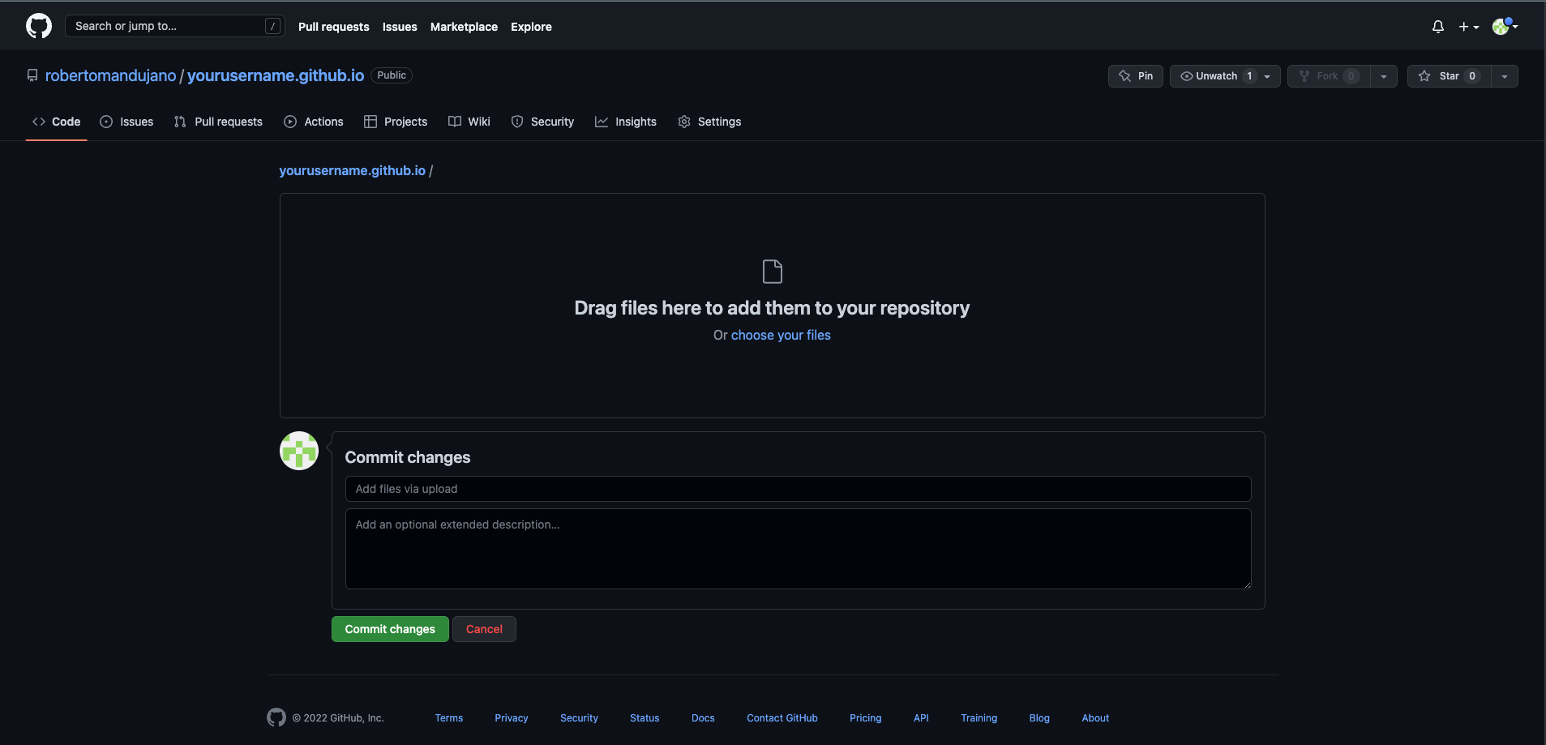

1. Once you have completed this step you can go to ***yourusername.github.io*** to view the webpage that was created.